DLL’s IN WINDOWS

Intriguing Introduction: Unveiling the Magic of Dynamic-Link Libraries (DLLs)

In the ever-evolving world of Windows programming, we've conquered the art of crafting standalone programs. Now, it's time to delve into the fascinating realm of dynamic-link libraries (DLLs), one of the cornerstones of Windows architecture. These enigmatic modules, often referred to as shared libraries or simply dylibs, play a crucial role in the intricate dance of Windows applications.

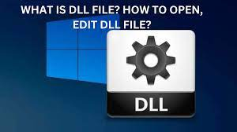

Imagine a vast library filled with countless volumes, each one holding specific functionalities that various programs can draw upon. That's essentially what DLLs are! They store reusable code and resources, acting as shared building blocks for multiple programs. This not only reduces redundancy but also boosts efficiency, since programs don't need to carry duplicate copies of the same functionality.

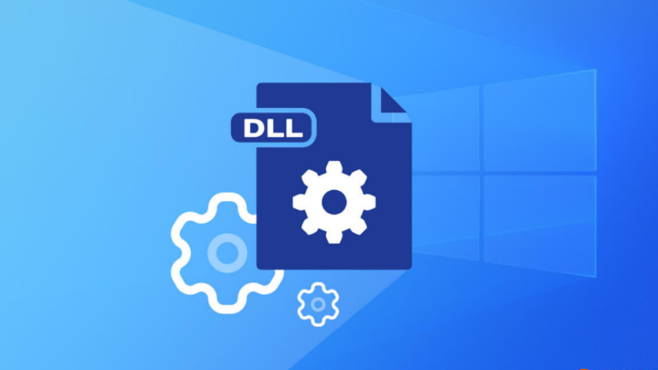

Most of those seemingly endless Windows files you encounter? A significant portion are either full-fledged programs or these dynamic powerhouses masquerading as DLLs. Now, buckle up, fellow coder, because we're about to embark on a journey into the exciting world of DLL creation!

While fundamental programming principles remain the backbone of both program and DLL development, subtle yet crucial differences emerge. We'll dive into these distinctions, equipping you with the knowledge and tools to craft your own dynamic-link masterpieces.

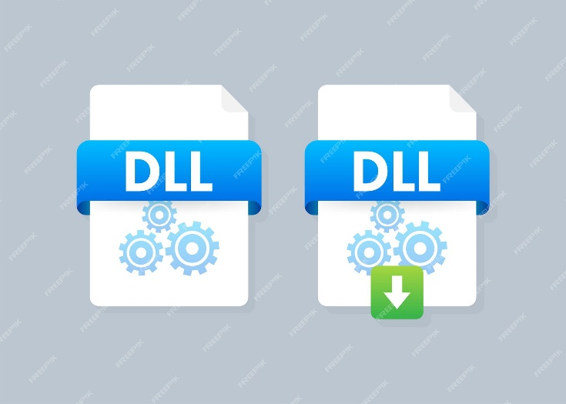

So, get ready to:

* Unravel the mysteries of DLL structure and function exports.
* Master the art of interfacing with programs through well-defined APIs.
* Grasp the intricacies of memory management and dynamic loading.
* Navigate the nuances of thread safety and resource sharing.

By the end of this chapter, you'll be well on your way to becoming a dynamic-link demigod, wielding the power of these versatile modules to enhance your Windows programming repertoire. So, let's embark on this adventure together and unlock the magic of DLLs!

UNLOCKING THE POWER OF SHARED LIBRARIES:

Distinct from Executables: DLLs aren't standalone programs. They're separate files containing functions and resources that can be called upon by programs and other DLLs.

Dynamic Linking at Runtime: Unlike static linking during program development, dynamic linking occurs when a program actually runs. Windows links function calls in the program to the corresponding functions within the DLL, enabling seamless code sharing.

The Fabric of Windows:

Core System Components: KERNEL32.DLL, USER32.DLL, GDI32.DLL, device drivers, and font files are examples of DLLs that form the foundation of Windows functionality.

Extension to Windows: Creating a DLL is essentially extending Windows’ capabilities, offering reusable code and resources to other programs.

Flexible File Extensions:

Standard .DLL: While DLLs can bear various extensions, .DLL is the most common.

Automatic Loading: Windows automatically loads DLLs with the .DLL extension. Other extensions require explicit loading using LoadLibrary or LoadLibraryEx functions.

Advantages of DLLs:

Code Reusability: Multiple programs can leverage the same DLL, reducing code duplication, conserving disk space, and streamlining memory usage.

Modular Updates: Changes to DLLs can be made independently without relinking dependent programs, simplifying maintenance and updates.

Sharing Resources: DLLs foster efficient resource sharing, including fonts, icons, images, and other non-executable data.

Ideal for Large Applications:

Common Routines: In extensive applications with multiple programs, DLLs house frequently used functions, promoting code efficiency and maintainability.

Accounting Example: An accounting package with many programs could benefit from sharing common routines within an ACCOUNT.DLL, reducing redundancy and enhancing update management.

Creating Viable Products:

Independent Products: DLLs can be standalone products licensed for inclusion in other programs, expanding their reach.

3D Drawing Example: A GDI3.DLL containing 3D drawing routines could be licensed to multiple graphics programs, ensuring users only need a single copy of the DLL.

DISSECTING THE LIBRARY LANDSCAPE:

Conquering Confusion: The term "library" wears multiple hats in Windows programming, each with a distinct role. Let's dive into their unique contributions.

Dynamic-Link Libraries (DLLs): Sharing the Wealth of Code and Resources

Building Blocks of Windows: DLLs are like LEGO® bricks, forming the core of Windows functionality and enabling versatile code and resource sharing.

Shared Resources for All: Imagine a community library where programs can borrow functions and resources, fostering efficiency and collaboration.

Dynamic Partnerships: DLLs join programs at runtime, forming adaptable alliances that streamline code execution and reduce redundancy.

Object Libraries (.LIB Files): Statically Linking for Integration

Becoming One with the Program: Think of object libraries as essential ingredients blended directly into a program's executable, ensuring their permanent presence.

The Foundation Beneath: They provide foundational code that supports essential tasks, like the C runtime library (LIBC.LIB) offering core functionality.

Import Libraries: The Architects of Dynamic Linking

Blueprints for Collaboration: Import libraries act as skilled architects, providing the linker with detailed plans for constructing connections between programs and DLLs.

Bridging the Gap: They facilitate communication and cooperation, translating function calls within programs into specific instructions for DLL interactions.

Key Differences and Usage: Understanding the Timing and Purpose

DLLs: Runtime Collaborators: Like trusted colleagues, DLLs join programs in action, providing their expertise at the moment of need.

Object and Import Libraries: The Development Team: These libraries contribute during the initial development phase, setting the stage for successful runtime partnerships.

DLL Loading: Searching for the Right Partner

Windows Plays Matchmaker: Windows diligently searches for required DLLs, following a specific path to ensure programs can connect with their necessary collaborators:

* Program's home directory.
* Current working directory.
* Windows system directory.
* Windows directory.
* Directories listed in the PATH variable.

Mastering Workspaces and Projects: A Foundation for Organized Development

Think of workspaces as spacious studios where multiple projects can coexist harmoniously. They offer a bird's-eye view of your development landscape, ensuring a well-coordinated workflow.

Projects, on the other hand, are like focused workshops dedicated to crafting specific components, whether they be dynamic-link libraries or standalone applications.

Key Considerations for DLL Project Setup:

Directory Structure: Placing both the workspace and project within the same root directory streamlines file management and simplifies the development process. It's akin to having all your tools and materials within arm's reach in a well-organized workspace.

Header Files: These blueprints of the DLL act as communication bridges, defining functions and structures that other programs can interact with. They ensure a common understanding of the DLL's capabilities, fostering seamless collaboration.

Source Files: Containing the actual code implementation, these files are where the magic happens. They bring the DLL's functionality to life, empowering other programs to leverage its capabilities.

Analogies for Enhanced Understanding:

Think of DLLs as shared toolboxes: Multiple programs can access the same tools (functions and resources) within a DLL, promoting efficiency and code reusability.

Imagine workspaces as construction sites: They provide the overarching structure for managing multiple projects, ensuring a cohesive development process.

Projects are like individual buildings: Each project focuses on a specific component, contributing to the overall construction of a robust software application.

Stay Curious, Stay Engaged:

As we delve deeper into the contents of EDRLIB.H and EDRLIB.C, we'll uncover the intricate details that shape the DLL's functionality.

The creation of the test application EDRTEST.EXE will reveal the dynamic interplay between the DLL and the program, showcasing the power of shared code and resources.

Embrace the journey of discovering the multifaceted world of DLLs, and prepare for even more exciting concepts and techniques as we progress!

EDRLIB.H

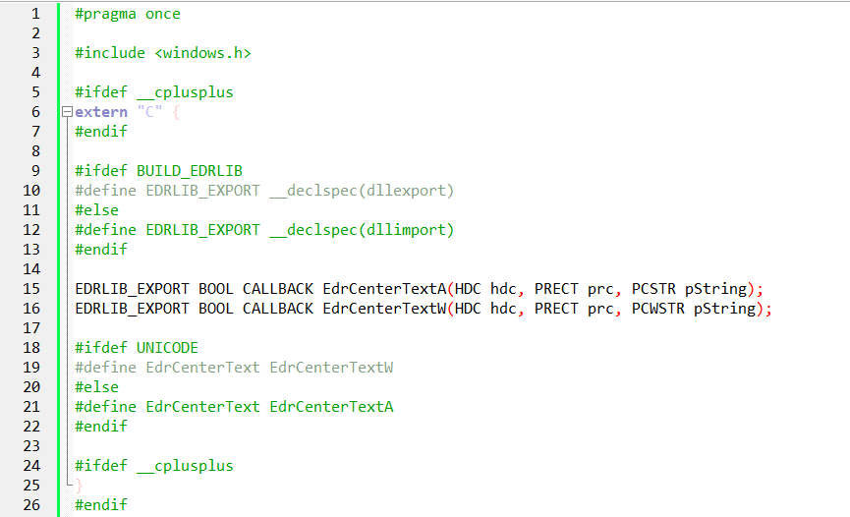

The code snippet you provided showcases the usage of the #pragma once directive and the __declspec(dllexport) and __declspec(dllimport) attributes in C/C++ code.

*#pragma once:*

The #pragma once directive is a non-standard but widely supported preprocessor directive that ensures a header file is included only once during compilation, regardless of how many times it is referenced. It acts as an include guard, preventing multiple inclusions of the same header file, which can cause compilation errors due to duplicate definitions.

*__declspec(dllexport) and __declspec(dllimport):*

These attributes are Microsoft-specific and are used for exporting and importing functions and data from dynamic-link libraries (DLLs) in Windows.

* __declspec(dllexport) is used to specify that a function or data item should be exported from a DLL. When a DLL is built with this attribute, the functions or data can be accessed by other modules (exe files or other DLLs) that link against the DLL.
* __declspec(dllimport) is used to specify that a function or data item is imported from a DLL. When a module (exe file or DLL) is built with this attribute, it indicates that the functions or data are defined in an external DLL and should be resolved at runtime.

*EDRLIB_EXPORT:*

``EDRLIB_EXPORT is a preprocessor macro that is defined based on whether theBUILD_EDRLIBmacro is defined. IfBUILD_EDRLIBis defined, EDRLIB_EXPORTis set to__declspec(dllexport), indicating that the associated functions or data items are being exported from the DLL. If BUILD_EDRLIBis not defined, EDRLIB_EXPORTis set to__declspec(dllimport)`, indicating that the associated functions or data items are being imported from the DLL.

*Function declarations:*

The code snippet declares two functions: EdrCenterTextA and EdrCenterTextW. The A and W suffixes indicate that these functions have ASCII and wide-character (Unicode) versions, respectively. The functions take an HDC (handle to a device context), a pointer to a RECT structure, and a string as arguments.

*EdrCenterText macro:*

The EdrCenterText macro is defined based on whether the UNICODE macro is defined. If UNICODE is defined, the macro expands to EdrCenterTextW, which refers to the wide-character version of the function. If UNICODE is not defined, the macro expands to EdrCenterTextA, which refers to the ASCII version of the function.

*extern "C":*

The extern "C" block is used to ensure that the function declarations have C linkage. This is important when the code is compiled with a C++ compiler to prevent name mangling, which allows the functions to be called from C code without any issues.

In summary, the code snippet provides a mechanism for exporting and importing functions from a DLL using the __declspec(dllexport) and __declspec(dllimport) attributes. The EDRLIB_EXPORT macro is used to conditionally apply the appropriate attribute based on the presence of the BUILD_EDRLIB macro.

The EdrCenterText macro allows for using either the ASCII or wide-character version of the function based on the UNICODE macro. The extern "C" block ensures that the function declarations have C linkage, enabling their use in both C and C++ code.

EDRLIB.C

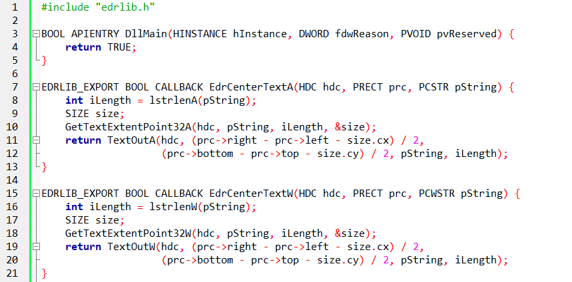

The code you provided is an implementation of the functions declared in the edrlib.h header file. It defines the behavior of the EdrCenterTextA and EdrCenterTextW functions. Let's break down the functioning of this code:

*BOOL APIENTRY DllMain*

This is the entry point function for the DLL. It is called by the operating system when certain events occur, such as the loading or unloading of the DLL. In this code, the DllMain function is a placeholder and returns TRUE without performing any specific actions. Depending on the requirements of your DLL, you can customize this function to handle initialization, cleanup, or other tasks.

*EDRLIB_EXPORT BOOL CALLBACK EdrCenterTextA*

This function is the implementation of the ASCII version of EdrCenterText. It takes an HDC (handle to a device context), a pointer to a RECT structure, and a null-terminated ASCII string as arguments. Within the function:

*lstrlenA(pString) calculates the length of the input string.*

GetTextExtentPoint32A determines the dimensions (width and height) of the text when drawn with the specified device context and font. The result is stored in the size structure.

TextOutA outputs the text to the specified device context. It calculates the position for centering the text within the given rectangle (prc) based on the text dimensions (size).

*EDRLIB_EXPORT BOOL CALLBACK EdrCenterTextW*

This function is the implementation of the wide-character (Unicode) version of EdrCenterText. It takes an HDC, a pointer to a RECT structure, and a null-terminated wide-character string as arguments. The function logic is similar to EdrCenterTextA, but it operates on wide-character strings using the corresponding wide-character Win32 API functions (lstrlenW, GetTextExtentPoint32W, TextOutW).

The EDRLIB_EXPORT macro ensures that these functions are properly exported from the DLL when building with BUILD_EDRLIB defined. It applies the __declspec(dllexport) attribute to indicate that the functions should be accessible from other modules that link against the DLL.

Overall, this code provides an implementation for centering text within a rectangle using either ASCII or wide-character strings, depending on the function called. It utilizes Win32 API functions to calculate the dimensions of the text and position it at the center of the given rectangle.

BUILDING THE DLL: UNVEILING THE TREASURE MAP AND THE TREASURE CHEST:

EDRLIB.LIB: This import library acts like a meticulously crafted treasure map, guiding the linker to the exact locations of functions and resources within the DLL. It's an essential tool for programs seeking to tap into the DLL's riches.

EDRLIB.DLL: This dynamic-link library is the treasure chest itself, holding the executable code that delivers valuable functionality to external programs. It's the embodiment of code reusability and modularity.

Navigating Text Encodings: Speaking Fluent ANSI and Unicode:

Separate Functions for Each Encoding: The DLL caters to both ANSI and Unicode text through thoughtful function pairs: EdrCenterTextA for ANSI and EdrCenterTextW for Unicode. It's like having a skilled translator who can seamlessly bridge different language worlds.

Choosing the Right Windows API Functions: The DLL carefully selects appropriate Windows API functions based on the text encoding, ensuring compatibility and accurate text handling. It's like using the right tools for the job, whether it's building a house with ANSI bricks or constructing a Unicode palace.

The UNICODE Switchboard: The #ifdef UNICODE block in EDRLIB.H acts as an intelligent switchboard, automatically directing calls to the correct text handling function based on the program's encoding settings. It's a clever mechanism that streamlines code maintenance and eliminates the need for manual configuration.

DllMain: The DLL's Gatekeeper and Life Cycle Manager:

Replacing WinMain: While WinMain is the heart of traditional Windows applications, DllMain takes on this central role in DLLs. It's the first function called when a DLL is loaded and the last function called when it's unloaded, making it responsible for essential initialization and termination tasks.

A Successful Start: In this particular DLL, DllMain simply returns TRUE, indicating successful initialization and a smooth start to the DLL's journey. It's like a green light signaling that the DLL is ready for action.

Exporting Functions: Opening Doors for Collaboration:

The EXPORT Macro: A Passport for Functions: The EXPORT macro, defined as extern "C" __declspec(dllexport), serves as a passport for functions, allowing them to cross borders and be used by external programs. It's a powerful tool for enabling collaboration and code sharing.

Function Visibility and Cross-Language Compatibility: The __declspec(dllexport) component makes functions visible within the DLL, ensuring they can be found and called by external programs. Meanwhile, extern "C" prevents C++ name mangling, promoting smooth communication between different programming languages. It's like ensuring everyone speaks the same language, fostering understanding and cooperation.

Key Takeaways: Building a Shared Code Universe:

* DLLs offer a potent path towards modularity and code reusability, but careful attention to text encoding is crucial to ensure broad compatibility and avoid communication glitches.
* DllMain serves as a pivotal gatekeeper and lifecycle manager, overseeing the DLL's smooth integration into the application landscape.
* The EXPORT macro acts as a bridge, opening up the DLL's functions to external programs and fostering a collaborative ecosystem of shared code resources.

EMBARKING ON THE DLL JOURNEY: INITIALIZATION AND BEYOND

When a DLL is loaded into a process's address space, a world of possibilities unfolds. This integration begins with the DLL_PROCESS_ATTACH event, signaling the genesis of DLL orchestration. During this stage, critical tasks such as memory allocation, resource acquisition, and setup of global variables take center stage. The successful execution of these steps sets the foundation for the smooth progression of the program.

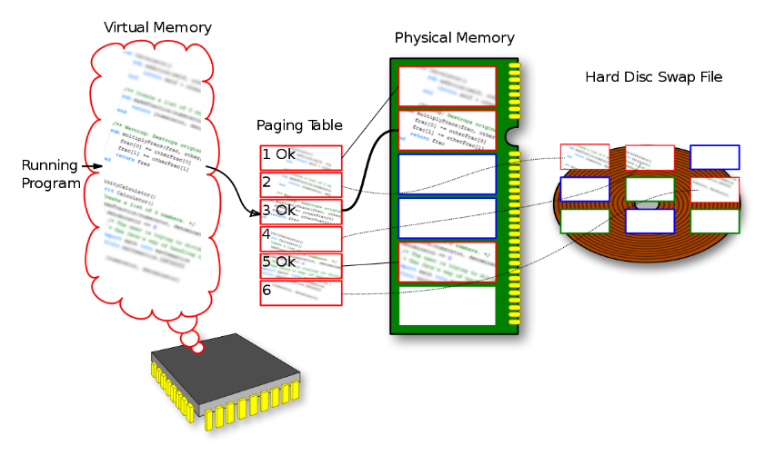

To ensure a seamless transition, it is essential to prioritize efficiency and brevity within the DllMain function. This function acts as the entry point for the DLL and plays a crucial role in its initialization. By carefully crafting DllMain, developers can avoid potential performance bottlenecks that might hinder the overall system performance. By keeping the code concise and focused, unnecessary delays and resource consumption can be minimized.



Moreover, comprehensive error handling strategies should be implemented within DllMain to safeguard against unexpected issues. Error handling mechanisms, such as proper exception handling or appropriate return codes, can help detect and gracefully recover from errors during the DLL's integration process. By proactively addressing potential failure scenarios, developers can enhance the reliability and stability of the DLL.



Additionally, it is crucial to prioritize thread safety within DllMain to prevent race conditions and maintain harmony within the system. Since multiple threads can concurrently access the DLL during its integration, synchronization mechanisms, such as locks or critical sections, should be employed to ensure data consistency and integrity. By meticulously guarding against thread-related issues, developers can mitigate potential conflicts and maintain the overall stability and correctness of the DLL.

The Art of Graceful Departure: Cleanup and Closure

DLL_PROCESS_DETACH: The DLL's Final Curtain Call

As the DLL's journey within a process nears its end, meticulous cleanup ensures a graceful exit. Releasing resources, closing handles, and finalizing any remaining tasks are of utmost importance. This diligent attention to cleanup tasks prevents memory leaks and resource conflicts, fostering a well-maintained and stable system.

Navigating the Threads of Execution: A Delicate Dance

1. DLL_THREAD_ATTACH: Welcoming New Threads to the Performance

When new threads emerge within an attached process, DllMain gracefully receives notification. If necessary, thread-specific initialization and synchronization measures are undertaken to ensure seamless collaboration and proper functioning.

1. DLL_THREAD_DETACH: Bidding Farewell to Departing Threads

As threads depart, they are given a respectful send-off. However, caution must prevail. It is advisable to avoid using PostMessage due to the potential loss of messages. Additionally, vigilance regarding thread synchronization is crucial to prevent data corruption and unexpected behavior.

Additional Pearls of Wisdom:

1. Global Instance Handle: A Key for Resource Access

The hInstance parameter, often stored globally, unlocks the DLL's resource potential, enabling the usage of dialog boxes and other resources.

1. Multiple Process Encounters

DllMain encounters each process that loads the DLL independently, even if multiple instances of the same program exist within the system.

1. Thread Synchronization: A Delicate Art

When DllMain accesses shared resources, meticulous thread synchronization is necessary to safeguard against data corruption and ensure predictable behavior.

Conclusion: Mastering the Orchestration

By comprehending the nuances of DllMain and adhering to best practices, developers possess the ability to craft well-behaved and adaptable DLLs that seamlessly integrate into the dynamic tapestry of Windows applications. Through careful attention to initialization, cleanup, and thread management, DLLs contribute to a harmonious and efficient software ecosystem.

EDRTEST PROGRAM

A Journey of Collaboration and Flexibility:

EDRTEST.C Embarks on a Quest: This program embarks on a journey to demonstrate the power of dynamic-link libraries (DLLs) by integrating functions from EDRLIB.DLL, showcasing the benefits of modularity and extensibility in software development.

A Windows Application with a Clear Purpose:

The Foundation: EDRTEST.C adheres to the core structure of a Windows program, establishing a window, a message loop, and a window procedure (WndProc) to interact with the operating system and respond to user events.

The Spotlight: The WM_PAINT message handler within WndProc takes center stage, acting as the catalyst for calling upon the DLL's expertise.

A Partnership with a Dynamic Library:

Bridging the Gap: The program seamlessly integrates with EDRLIB.DLL by incorporating the necessary header file, edrlib.h, revealing the accessible functions within the DLL.

The Call for Text Expertise: When the window receives a WM_PAINT message, signaling a need to refresh its visual content, WndProc meticulously orchestrates a series of steps:

Obtaining the Canvas: It acquires a device context (hdc), the virtual canvas upon which graphical elements will be painted.

Measuring the Stage: It retrieves the dimensions of the window's client area (rect), defining the boundaries for text placement.

Extending the Invitation: It ventures beyond its own code and extends an invitation to the DLL's EdrCenterText function, passing along essential parameters:

* The device context (hdc), providing the means for drawing.
* A pointer to the RECT structure (prc), outlining the text's intended canvas.
* The text string itself (pString), awaiting its moment in the spotlight.
* Releasing the Canvas: It gracefully releases the device context, ensuring proper resource management and concluding the painting process.

Embracing Modularity, Embracing Potential:

* Code Reusability Redefined: EDRTEST.C embodies the concept of code reusability, showcasing how DLLs enable developers to share and leverage functionality across multiple programs, fostering efficient development and maintainability.
* A Symphony of Extensibility: The program gracefully demonstrates its ability to expand its own capabilities by incorporating external libraries, showcasing a world of potential for limitless growth and adaptation.
* A Path to Independent Updates: DLLs offer the flexibility to be updated independently, allowing for bug fixes, enhancements, or even complete replacement without necessitating a full recompilation of the main program, fostering a more agile and adaptable software ecosystem.

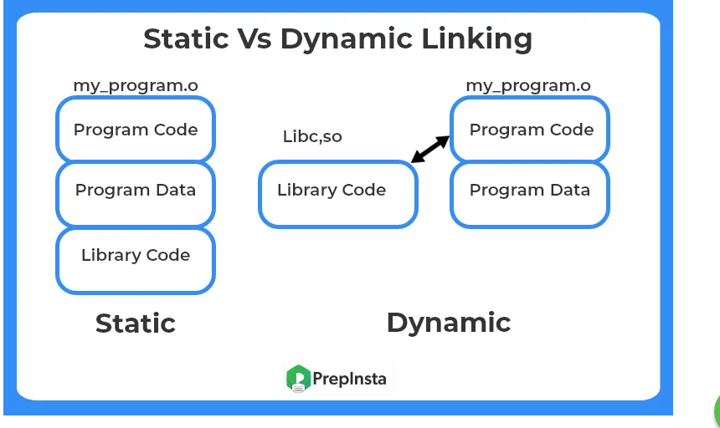

The provided program, EDRTEST.C, is an example program that utilizes the EDRLIB dynamic-link library (DLL). Let's break down the program into in-depth paragraphs:

Header Files and Declarations:

The program includes necessary header files, such as <windows.h>, and the header file for the EDRLIB DLL, "edrlib.h". It also declares the callback function WndProc and the WinMain entry point function.

Window Class Registration:

The program registers a window class by filling out a WNDCLASS structure. The WndProc function serves as the window procedure for handling messages associated with the application's window. The WNDCLASS structure specifies various attributes of the window, such as its style, background brush, icon, cursor, and class name. If the registration fails, an error message is displayed, indicating that the program requires Windows NT.

Window Creation and Display:

The program creates a window using the CreateWindow function. The window is given a title, dimensions, and window styles. The window is then shown and updated using the ShowWindow and UpdateWindow functions, respectively.

Message Loop:

The program enters a message loop using the GetMessage function. The loop retrieves messages from the message queue and dispatches them to the appropriate window procedure using the TranslateMessage and DispatchMessage functions. The loop continues until the WM_QUIT message is received.

Window Procedure:

The WndProc function handles messages sent to the program's window. In the case of the WM_PAINT message, the function begins painting by calling BeginPaint and obtains the client area's rectangle using GetClientRect. The EdrCenterText function from the EDRLIB DLL is then called to center the text "This string was displayed by a DLL" within the client area. Finally, the painting is ended using EndPaint.

Window Destruction:

If the program receives the WM_DESTROY message, it posts a quit message to the message queue using PostQuitMessage, which causes the message loop to exit.